Name: Sanika Botre PRN: 25070122063
Batch: 2025-29 Branch: CSE A-2
Subject: Programming with Java

ASSIGNMENT No: 3

TITLE : Develop a Java application demonstrating method overloading and the use of static variables, methods in class design.

Problem Statement: Develop a Java application demonstrating method overloading and the use of static variables, methods in class design.

Learning Objectives: To implement method overloading and use static variables and methods in Java programs.

Theory:

Method overloading allows multiple methods to have the same name with different parameter lists, enabling compile-time polymorphism. The static keyword is used for variables and methods that belong to the class instead of individual objects. Static members share common data among all objects and reduce memory usage. These concepts improve code flexibility, readability, and efficient resource management.

Exercise:

1. Develop a Calculator program using overloaded methods for addition of integers and decimals. Use a static variable to count calculations.

Code:-
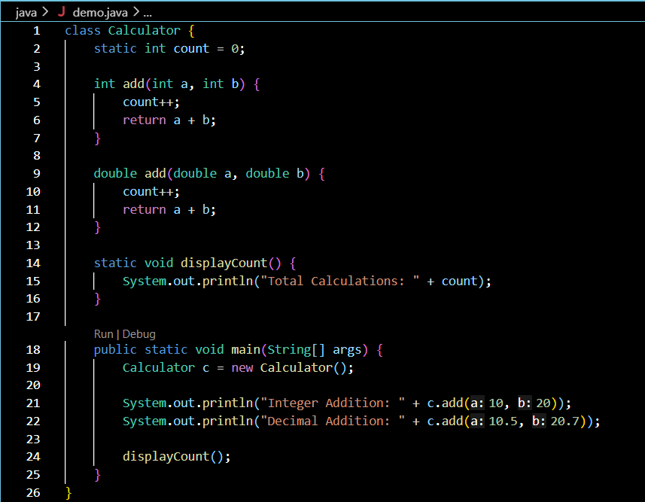

Output:-

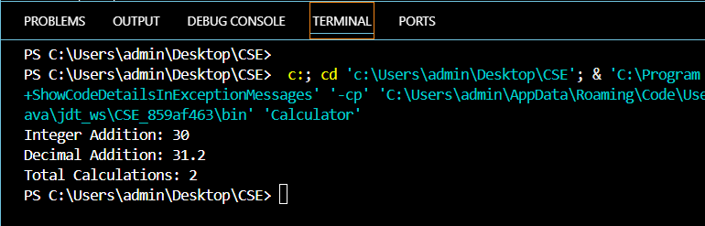

2. Develop a Restaurant Billing Application where overloaded methods calculate bills for dine-in, takeaway, and delivery orders, while static variables track total orders..

Code:-

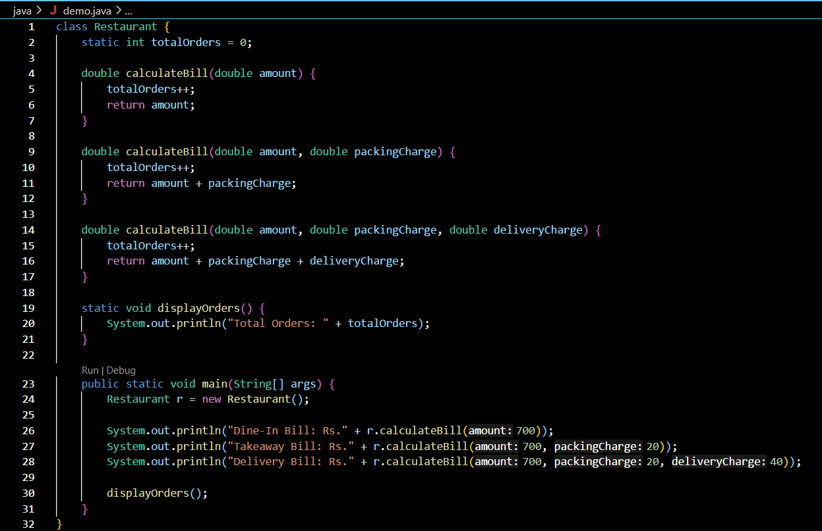

Output:-

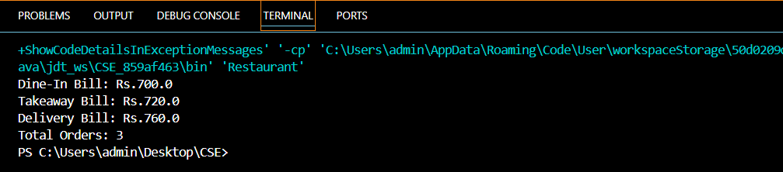

Conclusion:

The objectives of this assignment were achieved successfully. Method overloading was used to perform different operations with the same method name. Static variables and methods were implemented to manage class-level data efficiently. The programs produced the expected results without errors.This assignment improved the understanding of important Java programming concepts.

